
a
Company
Logotype

Cone Beam Computed Tomography- Report



Porur Dental X-rays & CBCT

Patient Name : Mrs. Meena. A | Date of Report : 25.04.2024
Age/ Gender : 40 years/ Female | Region of Interest : CBCT Full Skull
Referring doctor: Dr. B. Naveen Kumar | Indication : Implant assessment
Clinical Notes: Nil
PATIENT INFORMATION

CBCT- Full Skull provided
CBCT – IMAGE DETAILS

RADIOGRAPHIC INTERPRETATION

- No of teeth present in the maxillary and mandibular arch: 31; Missing tooth: 11.
- Horizontally placed teeth: 31, 41, 42.
- Presence of a single, irregular, hyperdense structure evident lingual to the teeth 31,32,41,42 positioned without contacting and above the alveolar ridge and measures 20 x 19.8 x 14.2 mm in dimension. The radicular portion of 31, 41, 42 are present exclusively in contact with the above irregular structure and are completely detached from the alveolar ridge.
- The teeth 32, 33 and 43 are present in contact with the irregular hyperdense structure, however the apical third of their radicular portions are within the alveolar bone.
- The maxillary and mandibular alveolar ridge are present with normal trabecular pattern.
- However, the alveolar ridge in relation to maxillary posterior teeth are present with resorptive changes leading to reduced bone density, bone width and bone height.

IMPLANT ASSESSMENT

 | 11 region
Sub-Crestal | 7.6
Mid- Crestal | 6.8
Distance between the alveolar ridge and Floor of the Nasal cavity (in mm) | 15.5

 | 41 region | 42 region | 43 region | 44 region
Sub-Crestal (in mm) | 7.6 | 7.8 | 6.4 | 10.4
Mid- Crestal (in mm) | 9.1 | 8.8 | 9.4 | 11.5
Distance between alveolar ridge and the inferior border of mandible (in mm) | 22 | 20.8 | 25.3 | 21.5
 | 31 region | 32 region | 33 region | 34 region
Sub-Crestal (in mm) | 7.7 | 5.6 | 8.5 | 8.9
Mid- Crestal (in mm) | 9.5 | 5.8 | 9.7 | 10.9
Distance between alveolar ridge and the inferior border of mandible (in mm) | 22.3 | 20.5 | 26.2 | 28.8

.

RADIOGRAPHIC IMPRESSION

- Partially edentulous maxillary arch.
- Generalized Chronic periodontitis.
- Avulsed teeth: 31, 41, 42.
- Calculus (Supragingival) in relation to the lingual region.

Kindly correlate with clinical findings


IMAGES FOR REFERENCE

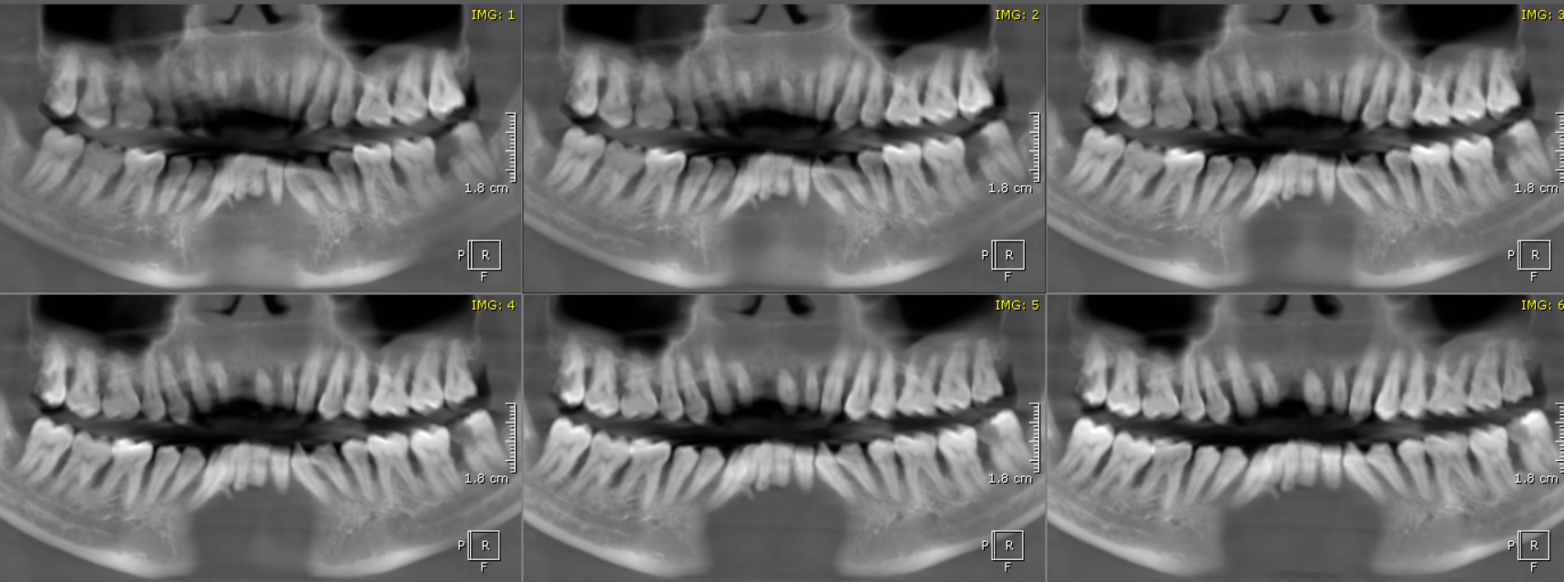
RECONSTRUCTED PANORAMIC VIEW

3-DIMENSIONAL VIEW

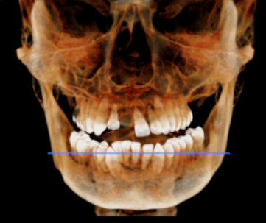

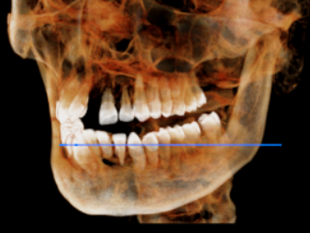
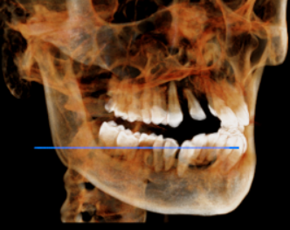

CROSS SECTIONAL VIEW

11 region | 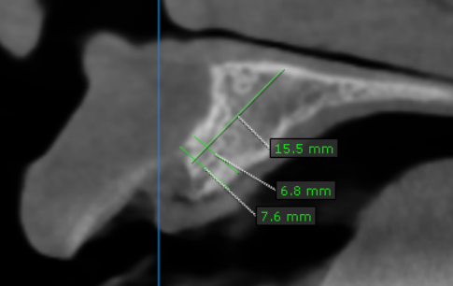
31 region | 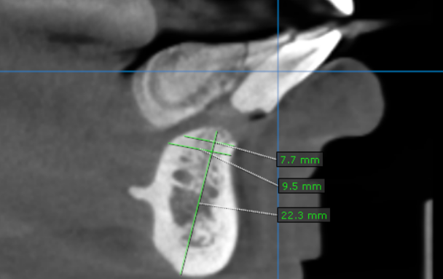
32 region | 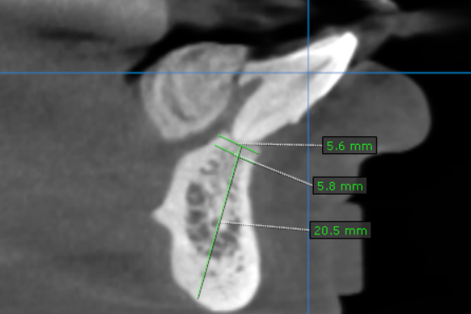
33 region | 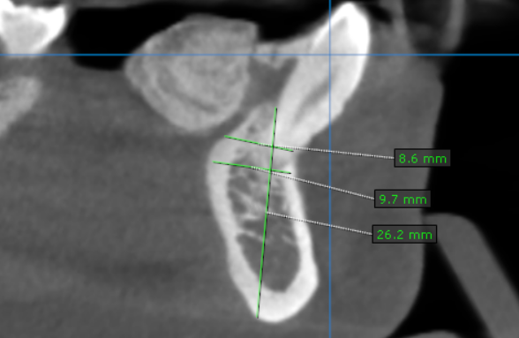
34 region | 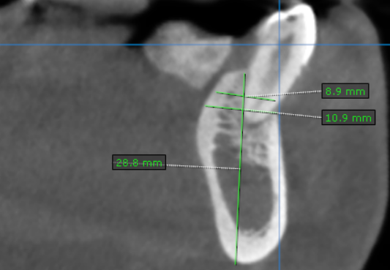
41 region | 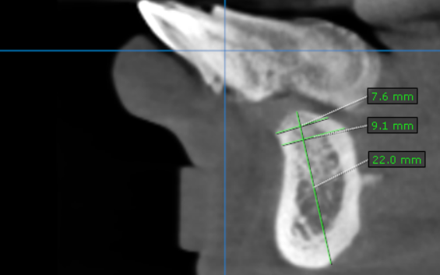
42 region | 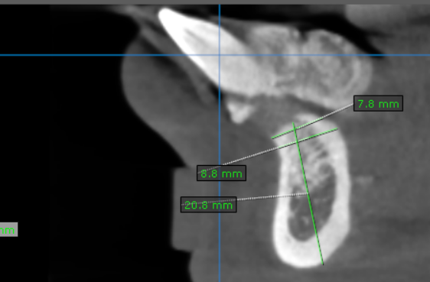
43 region | 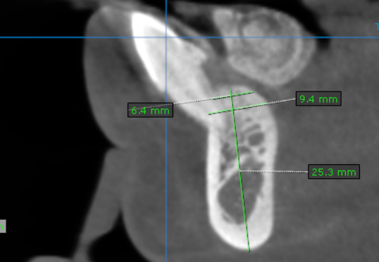
44 region | 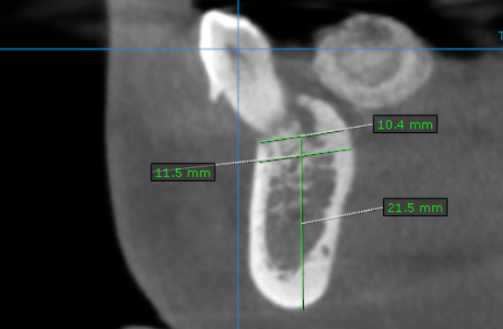

**** End of report ****

